Model WC6WA1010H specification

Pump:

High pressure pump type: dual intensifiers.
Maximum pressure: 380Mpa (55000psi).
Maximum water flow rate 5.5L/minute (1.4Gal/min)
Pump cooling method: Water cooling (water not re-used) is standard, electric chiller is optional.
Digital display of working pressure.
Water Filter: 2-stage water filtration included.
Minimum supply water pressure to pump: 70psi (5kg/cm²)
Approximate size: 65" x 60" x 60" (1600x1500x1500mm)
Power source: 3 phase, 220VAC 60Hz or (380VAC, 50Hz),
75kw, 100 HP. System starting current is about 250Amp.

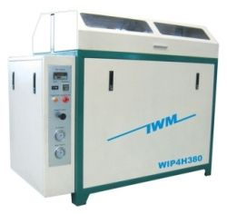

Cutting table:

Style: overpass
water tank made of stainless steel.
Effective cutting area: 3ft x 3 ft (1000x1000mm)
Maximum Z-axis travel: 6" (150mm)
X-Y axis motion system: ball screw, linear motion guide
X-Y axis motion drive: AC servo motor
Z axis motion: AC motor with speed reducer.
X-Y axis position repeatability: +/- 0.0009"(0.03mm).
Best cutting tolerance: +/- 0.006" (0.15mm).
Maximum X-Y axis travel speed: 32ft/min (10m/min).

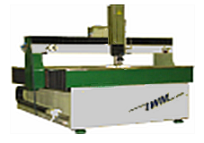

Cutting head:

Pneumatically operated on/off valve, self-aligned cutting head. Maximum Abrasive flow rate: 0.5kg/min (1lb/min). Compressed air source is necessary. An air compressor is optional item from manufacturer. As an option, the cutting head can manually tilt in both x and y directions.

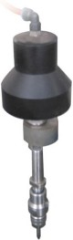

CNC controller:

Advanced industrial grade computer. The controller is capable of X-Y axis interpolation movement. Accelerate or decelerate the motion and high speed travel from point to point. Simulation without motion or dry run with axis motion but no jetting of water/abrasive are features included. Error stop and trace repeat are also very useful features. Out of range warning and hard stop to prevent damage of the cutting head. Emergency shut off switch is provided. Remote control is provided to move X-Y-Z axis when operator is away from the controller tower.

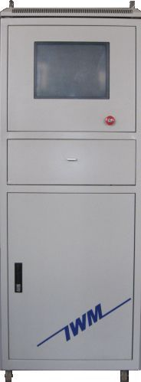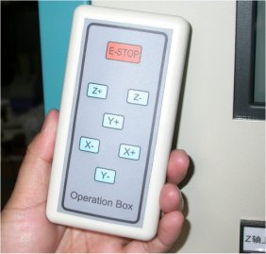

Controller Tower Remote Control

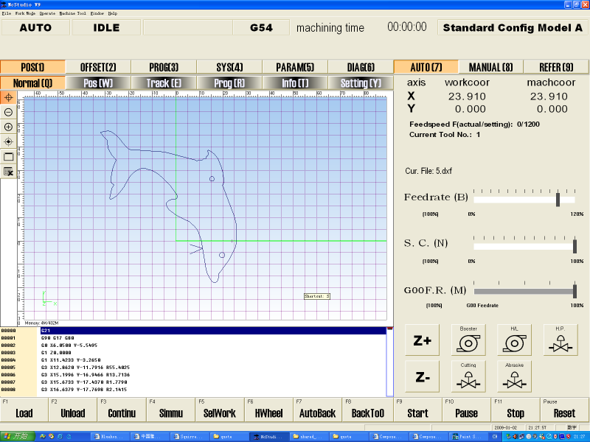

Controller Software screen

DXF file compatible:

The controller is compatible to dxf file format. Users can save design drawing in .dxf from AutoCAD and read the file into the controller. Controller will post the dxf file to G-code. The controller can also read G-code generated from other CAM software. Controller software interface is based on Microsoft Windows 98/XP/VISTA/Win7.

Advanced CAD/CAM software (optional): for design drawing, define machine path and lead in/out, nesting, tool offset, and generate G code. Features are similar to AutoCAD, and with rich features of CAM.

There are two paths to make the cut. First path uses a CAD software to draw the design, output file in dxf format.
The controller software then reads the dxf file and translates it to G-code (the controller machine language for controller to perform cutting. The second path also starts with a CAD software for drawing the design. Then the dxf is fed to the CAM software for nesting, lead in/out, offset, etc and finally output G-code. The G-code is read by the controller for cutting.

Automatic abrasive feeder (optional):

This equipment is highly recommended.
- Requires 70psi pneumatic source
- Capacity 40 Gallon.
- Self detecting empty/full status of reservoir and start/stop feeding.
- Model number ADS-04-170.

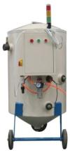

Accessories included in standard package:

High pressure tubing
Water hose
Electrical cables
1 pcs nozzle, 2 pcs orifice, 1 tube of blue goop.
1 set of special tools for pump maintenance.

